Audit Report

Front-end Web Development Path
Project 08
OpenClassrooms

BY

Hassan Kumail Ali

Dated: 19th March, 2021

Contents
Audit Report 1
1. Our App’s Features 3
1.1. Our App’s Performance Value on Desktop 3
1.2. Our App’s erformance Value on Mobile 3
1.3. Other Performance Metrics Screenshots 5
2. Competitor’s App Features 6
2.1. Competitors Performance Value on Desktop: 7
2.2. Competitors Performance Value on Mobile: 7
2.3. Other Performance Metrics Screenshots 7
3. Comparison by Actions Performed by User 9
Adding New Task: 10
Removing a Task: 10
Mark Task as Completed: 11
Marking All Tasks as Completed: 11
Deleted All Marked Tasks: 11
4. Comparison b/w Competitor and Our App 12
5. Summary 12

Our App’s Features
Compared to the competitor’s app, our app has a very limited set of features/functionalities. Following are some of the feature it has:
- Adding a To-do
- Marking a To-do as complete
- Marking all To-do’s as completed at once
- Deleting a To-do
- Toggle between All, Active and Completed To-do’s
- Clear all the completed to-do’s at once

Our App’s Performance Value on Desktop

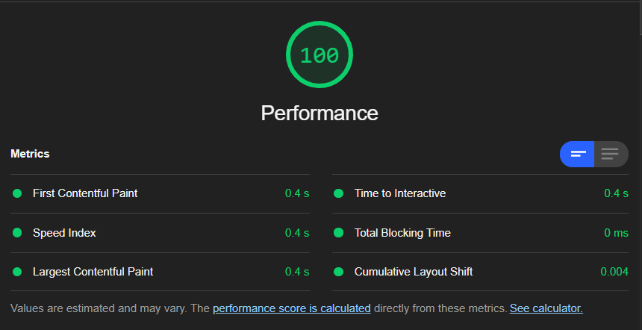

Our App’s erformance Value on Mobile

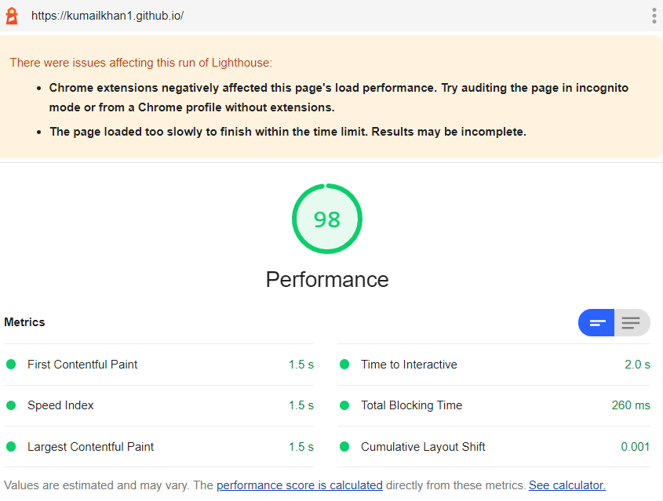

Other Performance Metrics Screenshots
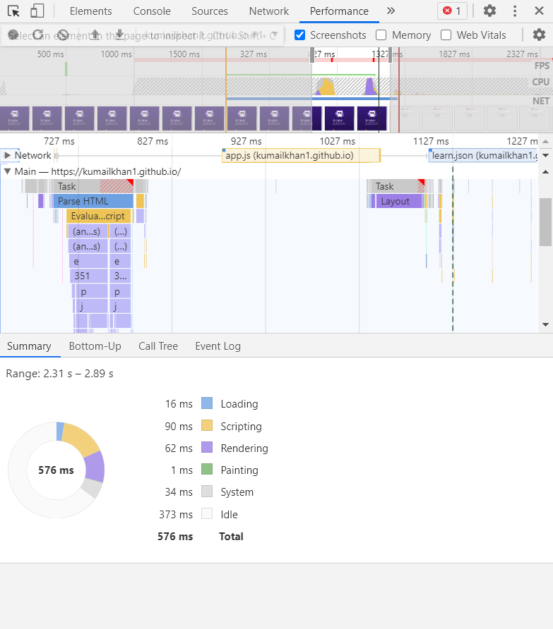
Figure 1 - Javascript Loading Time

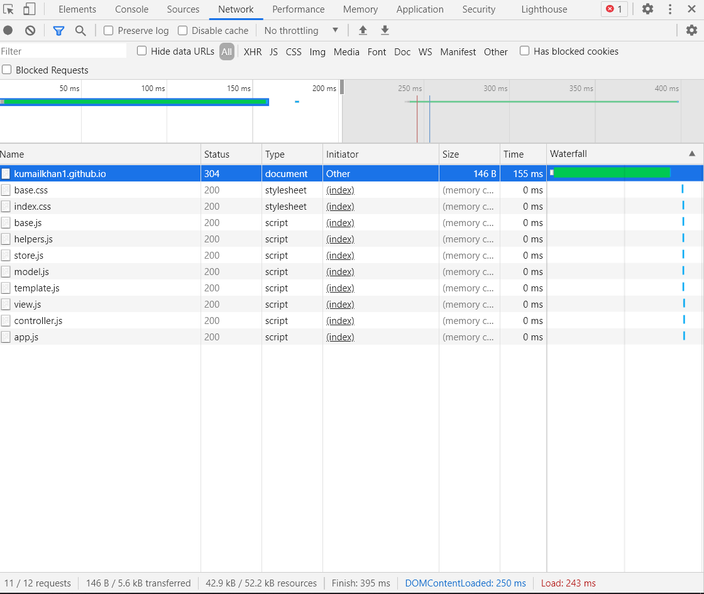
Figure 2 - Summary of Metrics (Data Transferred, Load Time etc)

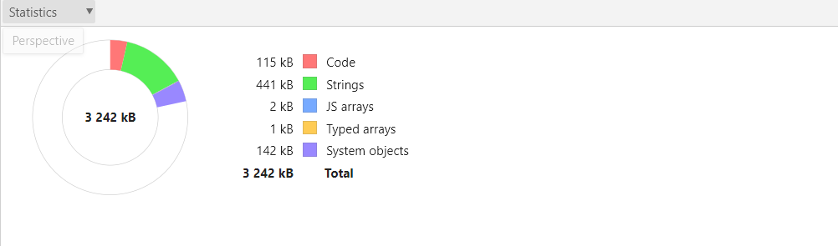
Figure 3 - Scripts Memory Consumption

Competitor’s App Features
Todolistme.net was audited. It is a much more complex application as compared to our app and has following extra functionalities:
- Adding new categories
- Adding multiple new lists
- Registration
- Synchronizing
- Drag and drop reordering of lists, or todo items.
- Printing the todo-list functionality
- Sorting with multiple filters

Competitors Performance Value on Desktop:

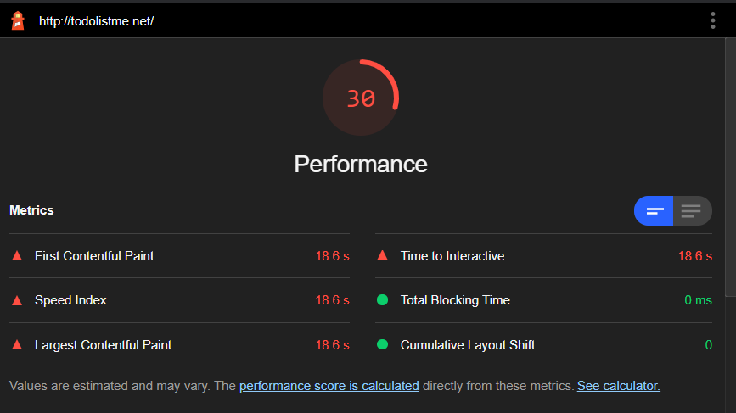

Competitors Performance Value on Mobile:

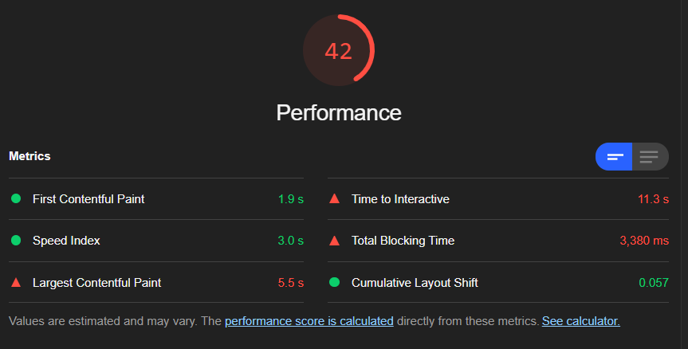

Other Performance Metrics Screenshots

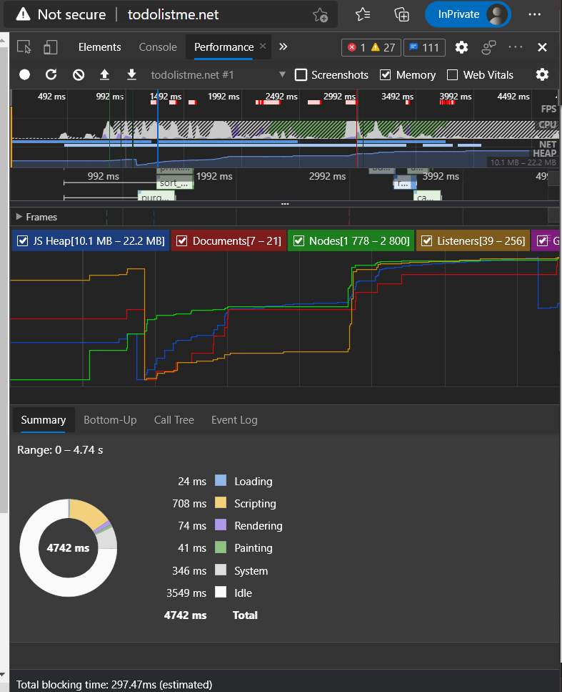
Figure 4 - Javascript Loading Time

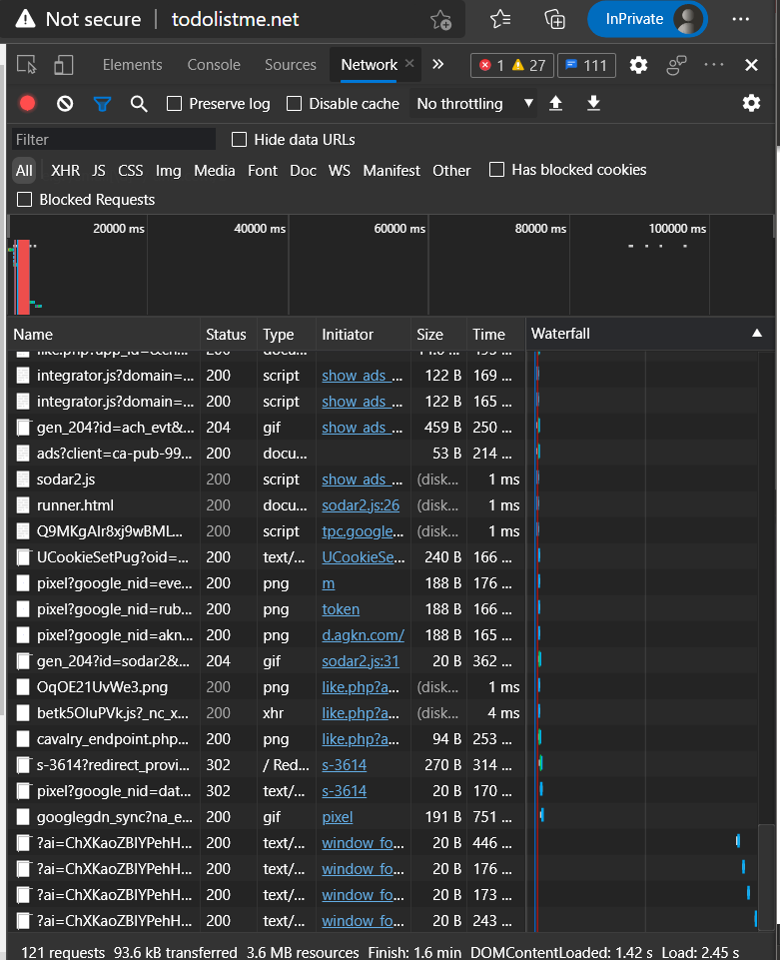
Figure 5 - Summary of Metrics (Data Transferred, Load Time etc)
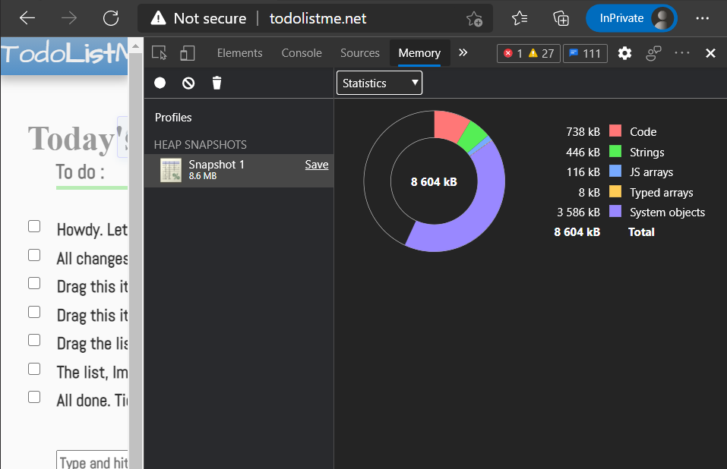
Figure 6 - Scripts Memory Consumption

Comparison by Actions Performed by User
Following is apple-to-apple comparison of the performance of actions performed that are common to both the apps.
We will subtract the idle time from the total to get near-to-actual value

Adding New Task:

Competitor’s App | Our App
348 – 206 = ~142 ms  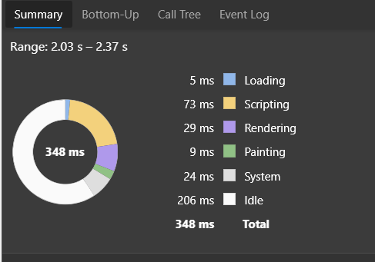 | 791 – 763 = ~28ms  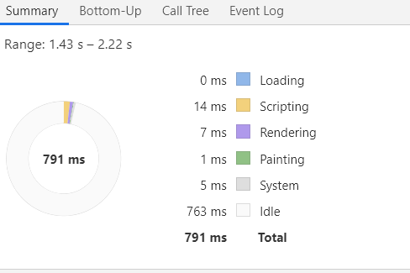

Removing a Task:

Competitor’s App | Our App
470 – 140 = 330ms  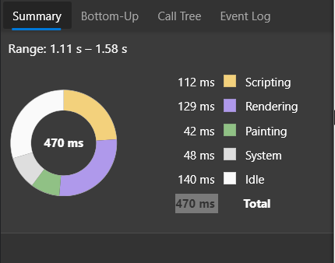 | 829 – 806 = 23ms  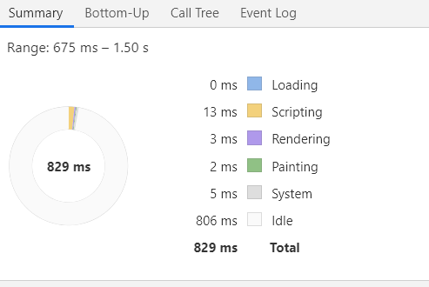

Mark Task as Completed:

Competitor’s App | Our App
362 – 111 = 251 ms  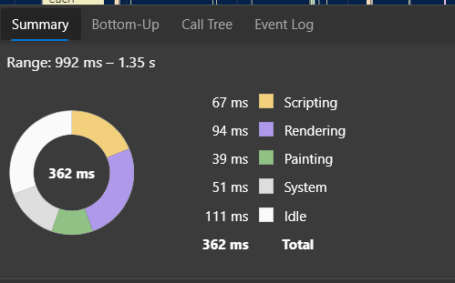 | 1562 – 1504 = 58 ms  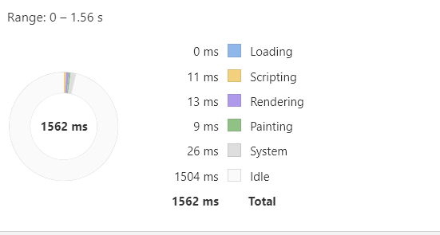

Marking All Tasks as Completed:
Not Available in competitors app

Deleted All Marked Tasks:

Competitor’s App | Our App
708 – 454 = 254 ms  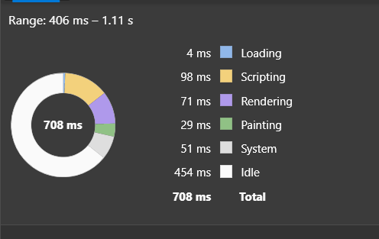 | 2692 – 2587 = 105 ms  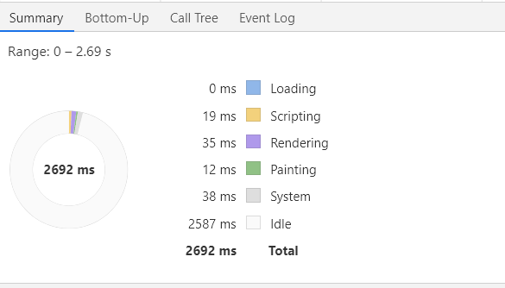

Comparison b/w Competitor and Our App

 | Competitor’s App | Our App
No. of Requests Made | 121 | 11
Transferred | 93.6kB | 0.14kB
DOM Loading Time | 1.42s | 0.25s
Page Loading Time | 2.45s | 2.43s
JS Memory Heap | 10.1MB – 22.2 MB | 3.2MB – 3.3 MB
Total Memory Consumption | 8.6MB | 3.2MB

Summary

It has been observed that our app outperforms the competitor’s app in terms of speed, loading time, memory consumption and overall performance. But the competitor’s app is feature-rich and quite complex. It provides the users with a number of extra useful functionalities that our app lacks. However, the difference in terms of speed of both apps is negligible and users would be willing to opt-for a more feature-rich app than to save their half a second here or there.

